Q1 :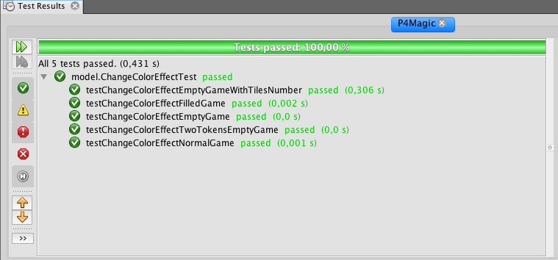

Q2 :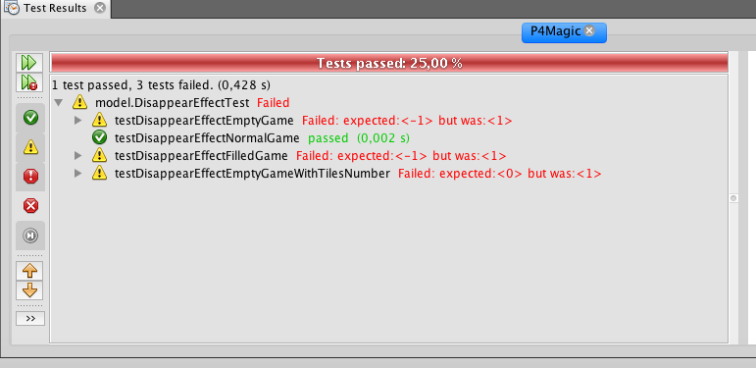

Q3 :

public class DisappearEffect extends Effect {

@Override

public void playEffect(int line, int column, Game game) {

int tile_id = game.getBoard().getTileIJ(line, column).getStatus();

int player1_id = game.getPlayer1().getId();

int p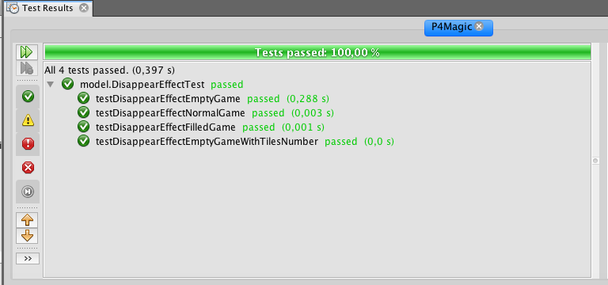layer2_id = game.getPlayer2().getId();

if (tile_id == player1_id){

tile_id = -1;

}

else if(tile_id == player2_id){

tile_id = -1;

}

game.getBoard().getTileIJ(line, column).setStatus(tile_id);

}

}

Q5 Ajout SupprimeColonneEffect :

public class DisparitionColoneEffet extends Effect {

@Override

public void playEffect(int line, int column, Game game) {

int i;

for(i = 0; i < 10; i++){

game.getBoard().getTileIJ(i, column).setStatus(-1);

}

}

}

Q6

Q7

Q8